DQN - Mountain Car
This document summarises online implementations of DQN for Mountain Car problem.

vikasjiitk/Deep-RL-Mountain-Car - :(
Link: https://github.com/vikasjiitk/Deep-RL-Mountain-Car
Files: MountainCar.py MCqlearn.py MCtest.py
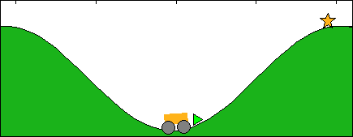
Params:
- Type: DQN with memory replay size 500
- Fancy: no target network
- Env: own
- Testing: Does not work, let it run for a while, doesn’t complete single episode
Output:
epoch step 0 86 [[-0.47329243 0.00459043]] -1 False
epoch step 0 87 [[-0.46708408 0.00620835]] -1 False
epoch step 0 88 [[-0.46030435 0.00677973]] -1 False
epoch step 0 89 [[-0.45200479 0.00829956]] -1 False
epoch step 0 90 [[-0.44324683 0.00875796]] -1 False
epoch step 0 91 [[-0.43309586 0.01015098]] -1 False
epoch step 0 92 [[-0.42362482 0.00947103]] -1 False
epoch step 0 93 [[-0.41290314 0.01072169]] -1 False
epoch step 0 94 [[-0.4030064 0.00989674]] -1 False
epoch step 0 95 [[-0.39400351 0.00900289]] -1 False
epoch step 0 96 [[-0.38395834 0.01004517]] -1 False

vmayoral/basic_reinforcement_learning - ???
Link blog: https://github.com/vmayoral/basic_reinforcement_learning
Link repo: https://github.com/vmayoral/basic_reinforcement_learning/blob/master/tutorial5/dqn-mountaincar.py
Params:
- DQN with memory 1000000
- Fancy: target network
- Env: OpenAI Gym
- Testing: none

jaara/AI-blog - Let’s make a DQN: DEBUGG - WORKS (with gym v0.9.5 FIX)
Link blog: https://jaromiru.com/2016/10/12/lets-make-a-dqn-debugging/
Link repo: https://github.com/jaara/AI-blog/blob/master/MountainCar-basic.py
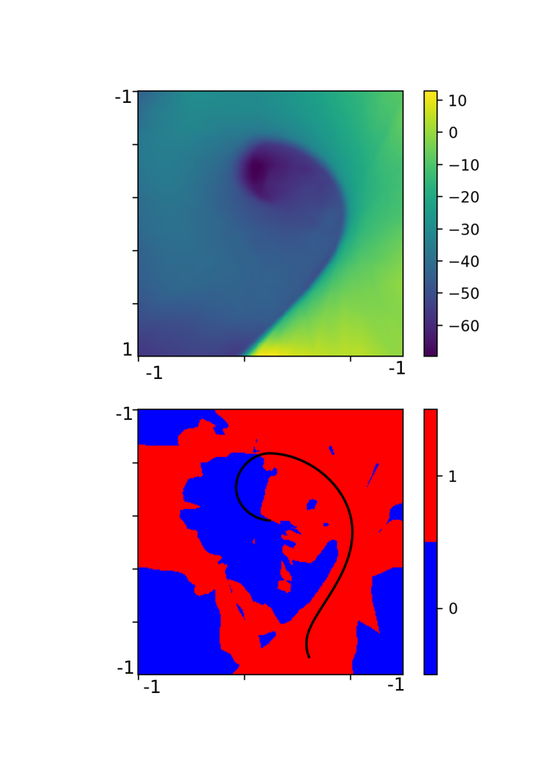
Params:
- DQN with memory 200000
- Fancy: no target network
- Env: OpenAI Gym
- Testing: Works with gym fix

ChiWeiHsiao/DeepRL - WORKS
Link: https://github.com/ChiWeiHsiao/DeepRL
Files: replay_memory_dqn.py
Params:
- DQN with 10000 memory
- Fancy: none?
- Env: own, modified for ease?
- Testing: WORKS

khanhptnk/deep-q-tensorflow - FAIL
Link: https://github.com/khanhptnk/deep-q-tensorflow
Params:
- Mountain-Car and Cart-Pole
- Fancy: Target network, double Q-learning
- CartPole learns to abuout 70-130 avg reward (should be >195)
- MountainCar completed single or non episodes during training

rlcode/reinforcement-learning - ???
Link Github: https://github.com/rlcode/reinforcement-learning
Link Repo: https://github.com/rlcode/reinforcement-learning/tree/master/4-gym/1-mountaincar
Params:
- Korean
- Fancy: Target network
- Env: OpenAI Gym
- Testing: really slow, doesn’t seem to finish single episode (after ep 45, so not too far)

Reinforcement Learning w/ Keras + OpenAI: DQNs - :(
Link Blog: https://towardsdatascience.com/reinforcement-learning-w-keras-openai-dqns-1eed3a5338c
Link Code: see blog post
Params:
- Really slow (?)
- Env: OpenAI Gym with modified reward
- Testing: Critical performance bug, too slow for reasonable assessment

